KLE Society's

KLE Technological University



**Open Ended Activity Report**

**On**

**ONLINE SHOPPING SYSTEM**

**Object Oriented Programming with C++ (19ECSC204)  
Object Oriented Programming with C++ Lab (18ECSP203)**

Submitted by

|  |  |  |
| --- | --- | --- |
| **Name** | **Roll no** | **SRN** |
| Srishti S Eligar | 137 | 01FE19BCS042 |
| Ankita A Mane | 146 | 01FE19BCS052 |
| Swathi Pardeshi | 153 | 01FE19BCS060 |
| Muskan R Havaldar | 165 | 01FE19BCS007 |
| **Team Number: 4A15** | | |
|  | | |

Faculty In-charge:

Somashekar Patil

SCHOOL OF COMPUTER SCIENCE & ENGINEERING

HUBLI – 580 031 (India).

Academic year 2020-21

1. **Introduction**
   1. Overview of the Problem Statement
   2. Features of Application
      1. Login of the Customer/Administrator
      2. Customer can buy products
      3. Administrator manages system
2. **Design** 
   1. Class Diagram
   2. Description of Each Class
   3. Main Function
   4. Use of Standard Design Patterns
3. **Unit Test Plan** 
   1. A
   2. b
   3. F
   4. T
4. **Implementation**
   1. Results
5. **Introduction**
   1. **Overview of the Problem Statement**

This project aims to develop an online shopping system for customers with the goal so that it is easy for them to carry out online shopping from their home. To get to this online shopping system all the customers as well as the administrators will need to have a username and password to login. Upon successful login the administrator can create - category and product. Customer service is accessible and the administrator takes care of it. Upon successful login the customers can purchase a wide range of products from the two departments available which is electronics and clothing. The system provides 3 modes of payments, i.e., Net banking, EMI or COD (Cash on delivery).

* 1. **Features of Application** 
     1. **Login of the Customer/Administrator**

If a Customer/Administrator already has an account he/she needs to enter their unique username and password only then he/she will login successfully. If the customer is new to the site, he/she has to register their account to proceed with the shopping on our online shopping system.

* + 1. **Customer can buy products**

After the successful login the customer can shop for desired products. The system comprises of two departments - Clothing and Electronics. Clothing has categories - men, women and kids. Electronics has categories - home appliances and gadgets. Once the customer confirms the order after successful payment, they receive shipping information.

* + 1. **Administrator manages system**

After the successful login the administrator can create new categories and products in the system. When the customer requires help or is facing any issue regarding the online shopping system administrator provides customer service.

1. **Design** 
   1. **Class Diagram**

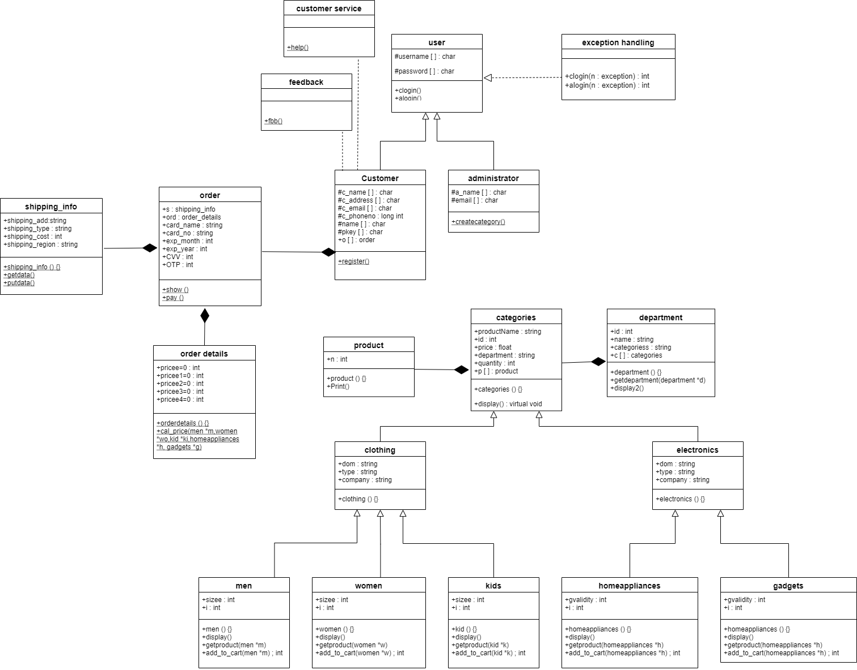

* 1. **Description of Each Class** 
     1. **User**

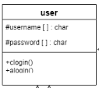

* User is an abstract class, here we have two functions clogin and alogin which are used by the users to login into the online shopping system after entering correct username and password.
* Username and password are two attributes of class user.
  + 1. **Customer**

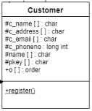

* As Customer is derived from the class user, it is child class of parent class user.
* It has c_name, c_address, c_email, c­_phoneno, name and pkey as attributes.
* The function register1 is used by the customers who are new to the system to create a new account.
* The customers can give feedback about the system and make use of customer services.
  + 1. **Administrator**

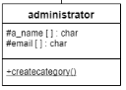

* As Administrator is derived from the class user, it is child class of parent class user.
* The protected attributes are: a_name and email.
* The public attributes used in the function are: c_id, d_id, c_name, c_desc.
* The function createcategory is used to create new categories as per the requirement
  + 1. **Exception Handling**

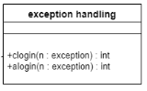

* Exception handling concept is used here in the class user so that when customer or administrator enter wrong username or password or both, it throughs exception informing the user about the same.
  + 1. **Department**

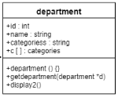

* Department class has attributes id, name and categories.
* The function getdepartment is used to get department id, name and number of categories it has, in to the file “department.txt” and display2 function is used to print the same.
* Department is the default constructor.
  + 1. **Category**

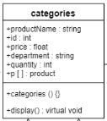

* Categories is an abstract class, it has a virtual function display.
* The attributes used here are: product name, id, price, department and quantity.
* Categories is the default constructor.
  + 1. **Clothing**

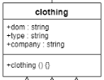

* Clothing is child class of parent class categories.
* It has attributes: dom, type, company.
* Clothing is the default constructor.
  + 1. **Electronics**

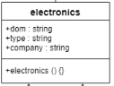

* Electronics is child class of parent class categories.
* It has attributes: dom, type, company.
* Electronics is the default constructor.
  + 1. **Product**

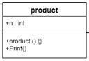

* Product class displays all the products available in the online shopping system.
* Product is the default constructor.
  + 1. **Men, Women and Kids**

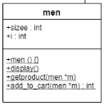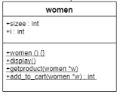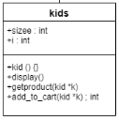

* Men, women and kid are child class of parent class clothing, clothing is child class of parent class categories, here we have multiple inheritance.
* Men, women and kid are is the default constructor.
* The display function here is overridden from the categories class.
* The function getproduct is used to get details of products in to their respective files “men.txt”, “women.txt” or “kid.txt”.
* The function add_to_cart is used to add the desired products into the shopping cart of the customer.
* Attributes used are size and i.
  + 1. **Home appliances and gadgets**

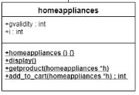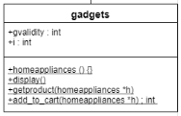

* Homeappliances and gadgets are child class of parent class electronics, electronics is child class of parent class categories, here we have multiple inheritance.
* Homeappliances and gadgets are is the default constructor.
* The display function here is overridden from the categories class.
* The function getproduct is used to get details of products in to their respective files “Homeappliances.txt” or “gadgets.txt”.
* The function add_to_cart is used to add the desired products into the shopping cart of the customer.
* Attributes used are gvalidity and i.
  + 1. **Order**

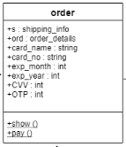

* Order class gives all the order details n shipping information.
* It has attributes (s and ord) of class shipping_info and order_details(composition-has a relation).
* Show function is used to show order details.
* Pay function is used to pay the total bill price .
  + 1. **Order details**

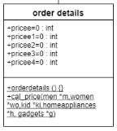

* Orderdetails class aggregate from class order.
* Orderdetails is default constructor.
* Cal_price function is used to calculate price and give total amount that customer pays after the order is confirmed.
  + 1. **Shipping information**

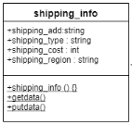

* Shipping_info class aggregate from class order.
* Shipping_info is default constructor.
* Getdata function is used to get shipping details of the customer and putdata is used to display the same.
  + 1. **Customer service**

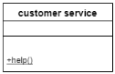

* This class is used to provide help to the customers when they face some problem, have issues/errors or need assistance.
  + 1. **Feedback**

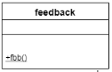

* This class is used to record the feedback of the customers and the end of their each shopping experience.
  1. **Main Function**

In main function we create a single object of user, customer, administrator, product, customer service and feedback, and two objects of men, women, kid and department. There is a switch menu for different options like login as existing customer or administrator or register if you are new customer. The customer has to first successfully login or register and login, then shop the required products from available categories and pay for it. The administrator manages the online shopping system.

* 1. **Use of Standard Design Patterns**

1. **Factory method pattern (creational pattern):**

* **Definition-** The Factory Method pattern is a design pattern used to define a runtime interface for creating an object. It’s called a factory because it creates various types of objects without necessarily knowing what kind of object it creates or how to create it.
* **Usage-** Factory method is suitable for this scenario because product objects are to be created as per user demand, so to create the objects during the run time interface it becomes easier.

1. **Template method pattern (Behavioral pattern):**

* **Definition-** In Template pattern, an abstract class exposes defined way(s)/template(s) to execute its methods. Its subclasses can override the method implementation as per need but the invocation is to be in the same way as defined by an abstract class.
* **Usage-** The display function of the class categories is overridden in men, women, kid, home appliances and gadgets. Display function is used in the same way as defined by the abstract class categories.

1. **Unit Test Plan**

**1.Process to login**

**- Customer login: clogin(), This process involves analyzing the details and checking the details of the person. Once the customer is able to login, it proceeds to the next stage, else, the exception handling section runs which involves giving a chance to enter proper details and exits. If the person is not an existing customer, he/she can register by creating a new account.**

**void clogin(char un[],char pw[])**

**{**

**ifstream fs("clogin.txt",ios::in);**

**for(int i=0;i<2;i++)**

**{**

**fs>>username>>password;**

**int n;**

**if (strcmp(un,this->username)==0 && strcmp(pw,this->password)==0)**

**{**

**cout<<" Welcome to customer"<<" "<<username<<endl;**

**cout<<" Press any key to continue shopping"<<endl;**

**break;**

**}**

**else**

**{**

**//exception handling**

**try**

**{**

**if(strcmp(un,this->username)!=0)**

**{**

**n=1;**

**}**

**if(strcmp(pw,this->password)!=0)**

**{**

**n=2;**

**}**

**if(strcmp(un,this->username)!=0 && strcmp(pw,this->password)!=0)**

**{**

**n=0;**

**}**

**throw n;**

**}**

**catch(...)**

**{if(n==1)**

**cout<<" enter correct the username"<<endl;**

**if(n==2)**

**cout<<" enter correct password "<<endl;**

**if(n==0)**

**cout<<" enter correct username and password\n";**

**exit(0);**

**}**

**}**

**}**

**fs.close();**

**}**

**- Administrator login: alogin(), This process involves analyzing and checking the details of the person.Once the administrator is able to login, he/she can create new categories and products. If the administrator is not able to login with his credentials then exception handling section runs.**

**//function for administrator login**

**void alogin(char un[],char pw[])**

**{**

**int n;**

**ifstream fs("alogin.txt",ios::in);**

**while(!fs.eof())**

**{**

**fs>>username>>password;**

**if(strcmp(un,this->username)==0 && strcmp(pw,this->password)==0)**

**{**

**cout<<" Welcome to administrator"<<" "<<username<<endl;**

**break;**

**}**

**else**

**{**

**//exception handling**

**try**

**{**

**if(strcmp(un,this->username)!=0)**

**{**

**n=1;**

**}**

**if(strcmp(pw,this->password)!=0)**

**{**

**n=2;**

**}**

**if(strcmp(un,this->username)!=0 && strcmp(pw,this->password)!=0)**

**{**

**n=0;**

**}**

**throw n;**

**}**

**catch(...)**

**{if(n==1)**

**cout<<" enter correct the username"<<endl;**

**if(n==2)**

**cout<<" enter correct password "<<endl;**

**if(n==0)**

**cout<<" enter correct username and password\n";**

**break;**

**}**

**}**

**}**

**fs.close();**

**}**

**};**

**2.Process to analyze the features**

**Once the customer logins,the customer will be able to access all these features.**

**(a).Department: This feature gives an overview of the departments and categories available for the customers.**

**(b).Categories and Products: This feature initially shows the existing categories and gives an option to select a particular category and browse the available products.The products have all the details,such as,product id which is very essential while ordering, product name,product type and many as such.**

**(c).Order: This feature helps the customer to order the products he/she wishes to buy by giving the specific product id and the quantity he/she wants.**

**(d).Payment: This feature gives 3 options to the customer on how to pay for his/her order and by giving the asked details. The 3 available options are,Card payments,Cash on delivery and Net banking.**

**(e).Customer Service: This feature helps the customer for his/her issues.**

**(f).Feedback: This feature allows the customer to rate the service of the shopping system according to his/her experience.**

**(g).Exit: This feature allows the customer to leave the portal.**

**cout<<" press 1 if you are an existing customer and you want to log in"<<endl;**

**cout<<" press 2 if you are a new customer and you want to register yourself"<<endl;**

**cout<<" press 3 if you are an administrator"<<endl<<endl;**

**cout<<" ";**

**cin>>ch;**

**if(ch==1)**

**{**

**cout<<" enter your username"<<endl;**

**cout<<" ";**

**cin>>uname;**

**cout<<" enter your password"<<endl;**

**cout<<" ";**

**cin>>pword;**

**u1.clogin(uname,pword);**

**main:**

**getch();**

**system("cls");**

**cout<<"\n Enter your choice:\n1.DEPARTMENT.\n2.CATEGORIES AND PRODUCTS\n3.ORDER\n4.PAYMENT METHOD\n5.HELP\n6.FEEDBACK\n7.EXIT\n\n\n";**

**cin>>ch2;**

**if(ch2==1)**

**{**

**for(int i=0;i<2;i++)**

**{**

**d[i].display2();**

**}**

**goto main;**

**}**

**else if(ch2==2)**

**{**

**pt.print(m,w,k,h,g);**

**cout<<"press any key to continue";**

**goto main;**

**}**

**else if(ch2==3)**

**{**

**o.show(m,w,k,h,g);**

**goto main;**

**}**

**else if(ch2==4)**

**{**

**o.pay();**

**goto main;**

**}**

**else if(ch2==5)**

**{**

**cs.help();**

**goto main;**

**}**

**else if(ch2==6)**

**{**

**fb.fbb();**

**goto main;**

**}**

**else**

**{**

**exit(0);**

**}**

**}**

**else if(ch==2)**

**{**

**c.register1();**

**mainnn:**

**getch();**

**system("cls");**

**cout<<" Enter your choice:\n1.DEPARTMENT.\n2.CATEGORIES AND PRODUCTS\n3.ORDER\n4.PAYMENT METHOD\n5.HELP\n6.FEEDBACK\n7.EXIT\n\n";**

**cin>>ch2;**

**if(ch2==1)**

**{**

**for(int i=0;i<2;i++)**

**{**

**d[i].display2();**

**}**

**goto mainnn;**

**}**

**else if(ch2==2)**

**{**

**pt.print(m,w,k,h,g);**

**goto mainnn;**

**}**

**else if(ch2==3)**

**{**

**o.show(m,w,k,h,g);**

**goto mainnn;**

**}**

**else if(ch2==4)**

**{**

**o.pay();**

**goto mainnn;**

**}**

**else if(ch2==5)**

**{**

**cs.help();**

**}**

**else if(ch2==6)**

**{**

**fb.fbb();**

**}**

**else**

**{**

**exit(0);**

**}**

**}**

**else if(ch==3)**

**{**

**int c;**

**cout<<" enter your username"<<endl;**

**cout<<" ";**

**cin>>uname;**

**cout<<" enter your password"<<endl;**

**cout<<" ";**

**cin>>pword;**

**u1.alogin(uname,pword);**

**cout<<" PRESS 1 IF YOU WANT TO ADD A NEW CATEGORY"<<endl;**

**cout<<" PRESS 2 IF YOU WANT TO EXIT"<<endl;**

**cout<<" ENTER YOUR CHOICE"<<endl;**

**cout<<" ";**

**cin>>c;**

**if(c==1)**

**{**

**a.createcategory();**

**}**

**else**

**{**

**exit(0);**

**}**

**}**

**}**

1. **Implementation**

**4.1] Home page and login**

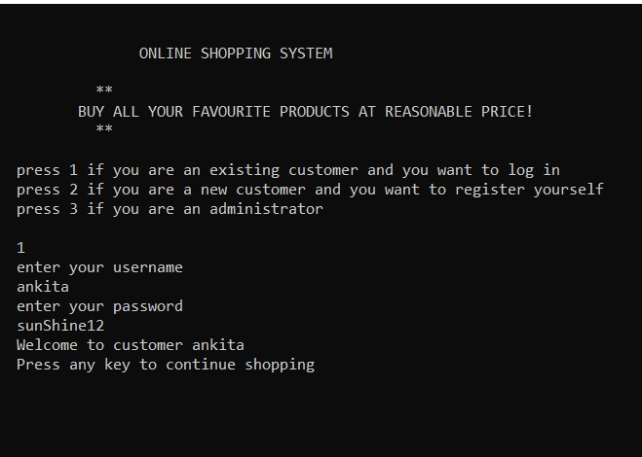

**4.2] New user registration**

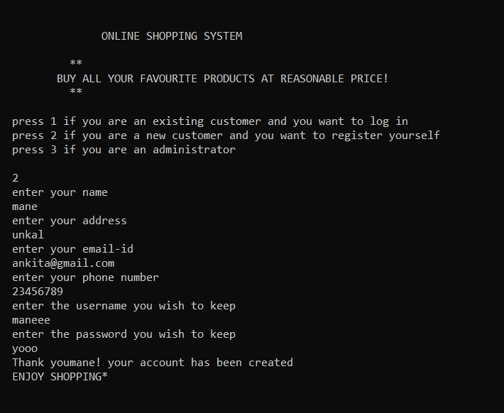

**4.3] Admistrator login**

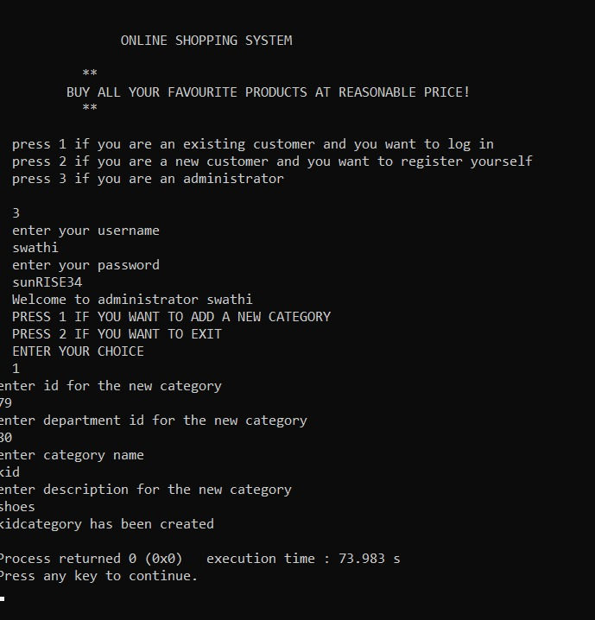

**4.3] displaying menu**

**I] choosing option 1 to display information about our different departments**

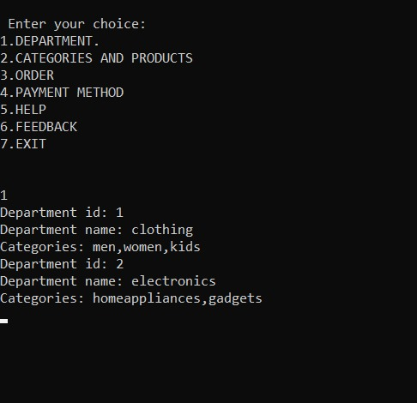

**4.3]**

**2] choosing option 2 to display information about our different categories and products**

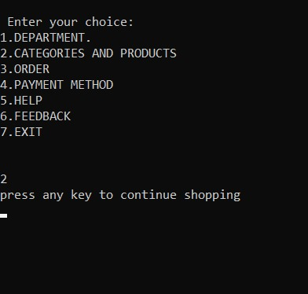

**4.3]**

**2] choosing option 2 to display information about our different categories and products**

**[i] choosing option 1 to display information about men’s section**

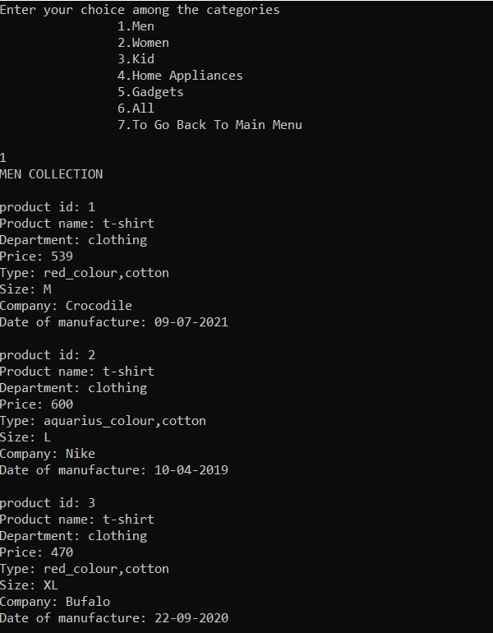

**4.3]**

**2]**

**[ii] choosing option 2 to display information about women’s section**

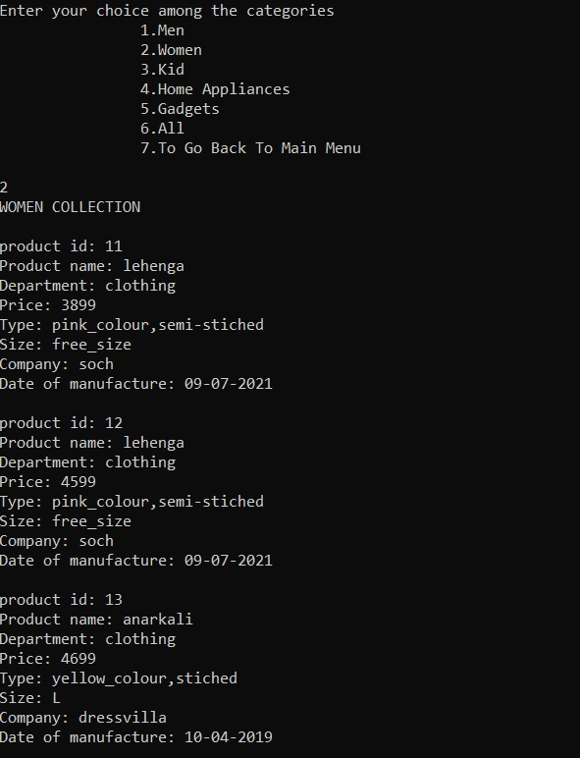

**4.3]**

**2]**

**[iii] choosing option 3 to display information about kids’ section**

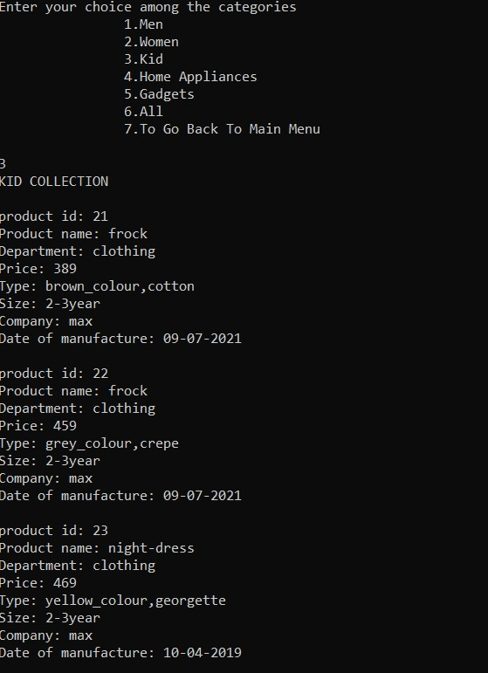

**4.3]**

**2]**

**[iii] choosing option 4 to display information about home appliances’ section**

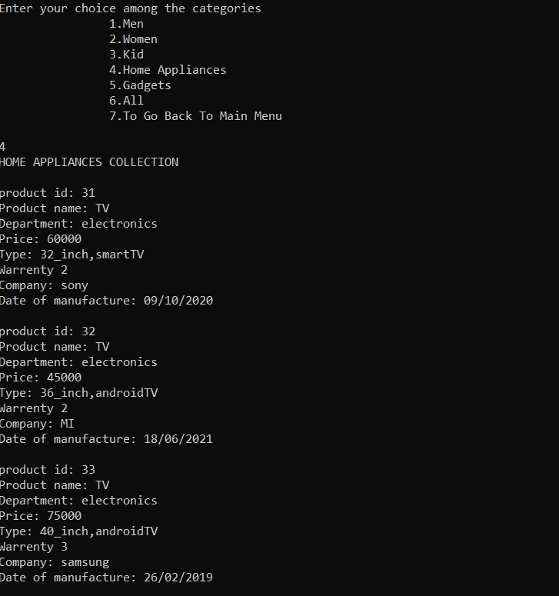

**4.3]**

**2]**

**[iii] choosing option 5 to display information about gadgets’ section**

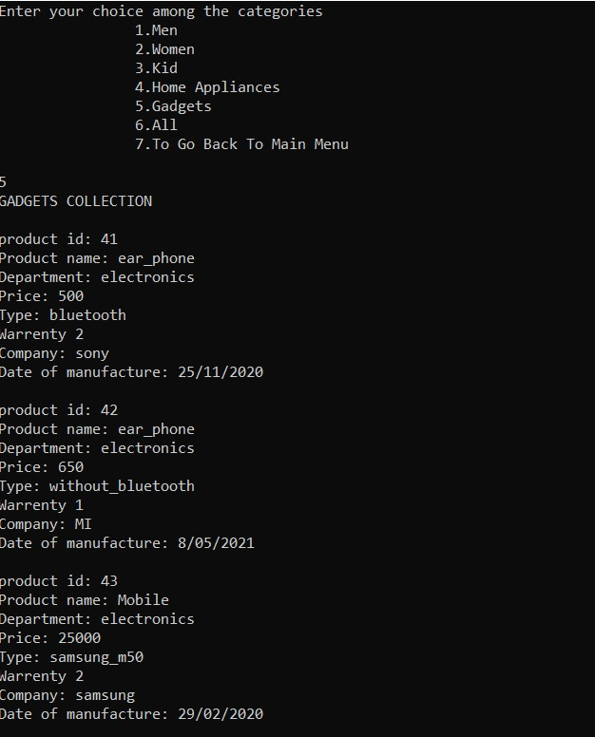

**4.3]**

**2]**

**[iii] choosing option 7 to go to the main menu**

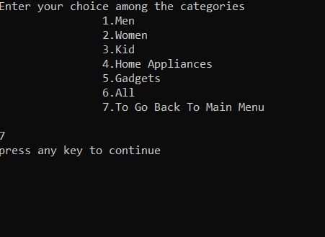

**4.4] Selecting option 3 to order from categories given below**

**1] Selecting option 1 to buy from the mens’ section**

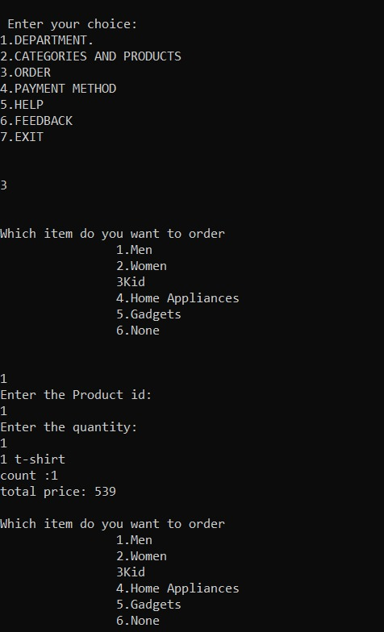

**4.4]**

**2] Selecting option 2 to buy from the womens’ section**

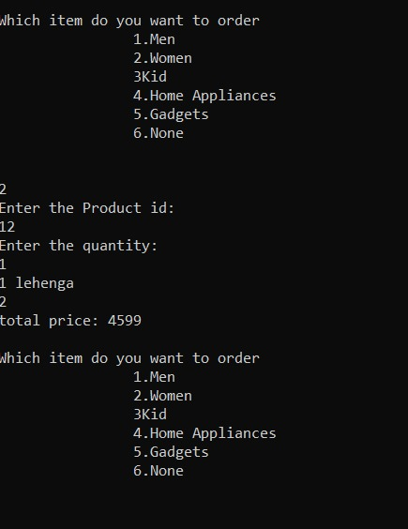

**4.4]**

**3] Selecting option 3 to buy from the kids’ section**

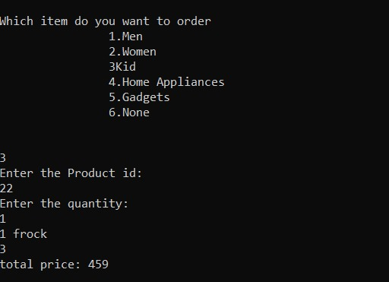

**4.4]**

**4] Selecting option 4 to buy from the home appliances’ section**

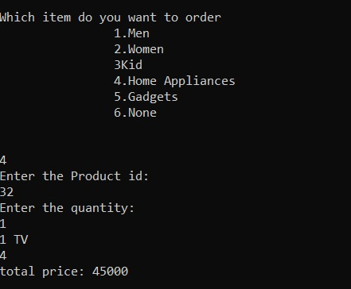

**4.4]**

**5] Selecting option 5 to buy from the gadgets’ section**

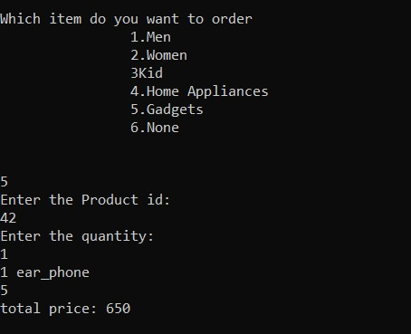

**4.4]**

**6] Selecting option 6 to stop buying and asking for shipping information**

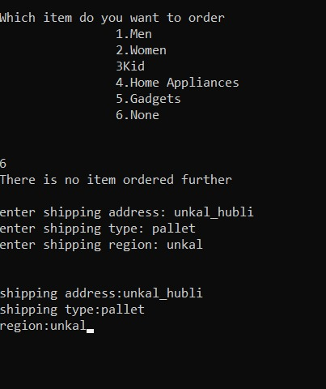

**4.5] Selecting option 4 for payment methods**

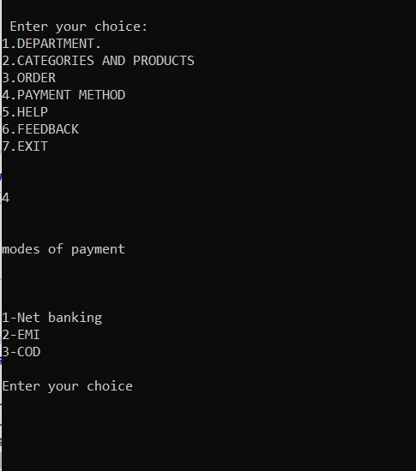

**4.5]**

**1] Choosing option 1 for net-banking**

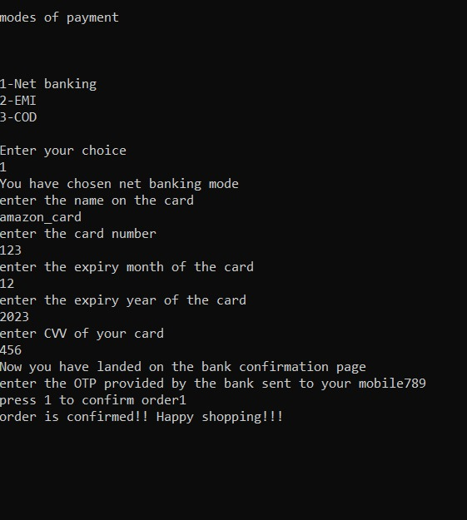

**4.5]**

**2] Choosing option 3 for cash on delivery**

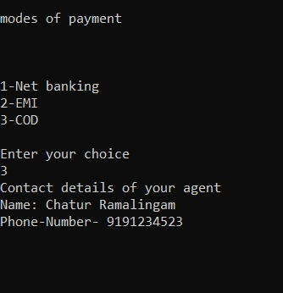

**4.6] Choosing option 5 if customer needs any help from our end**

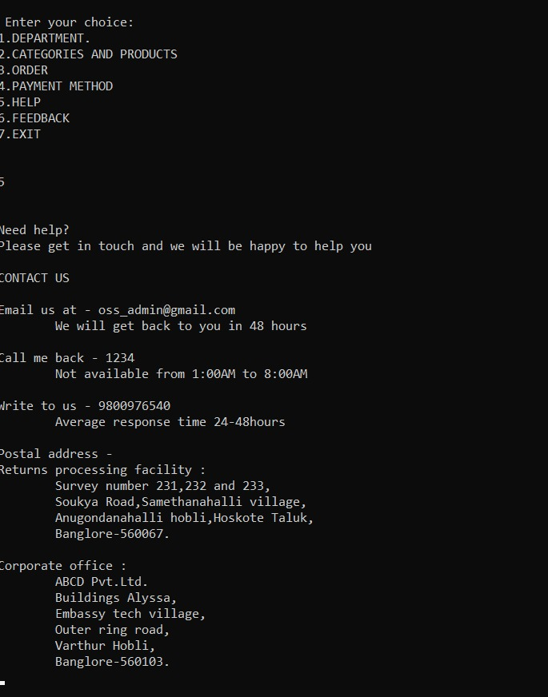

**4.7] Choosing option 6 for feedback**

